# e-Cat Change Requests Airtable Maintenance Guide

This document provides instructions for maintaining the **e-Cat Change Requests** Airtable base.

**NOTE,** this is a guide only for maintaining this base, not for using Airtable. Resources for using Airtable are provided here and at other points in this document.

**Maintaining this document**

1. Download the file from the Developer Documentation table in the e-Cat Change Requests base.
2. Make edits in MS Word and note your changes in the Version table below. Remember to update the TOC.
3. Add a row to the Developer Documentation table.
4. Attach the edited file.
5. Fill in the fields and identify the Version # in the Title.

For questions, contact [jmaltese@rh.com](mailto:jmaltese@rh.com).

|  |  |  |  |
| --- | --- | --- | --- |
| Version # | Author | Changes | Date |
| 1 | Joan Maltese | Original | 12/30/24 |
| 2 |  |  |  |

Table of Contents

e-Cat Change Requests Airtable Maintenance Guide 1

Updating e-cats 2

Export the latest data from Galaxy 2

Update the lookup tables 4

Spread Letters 5

Page Numbers 6

Project Codes 6

Add the new book 6

Mark the existing (now old) book 7

Questions 8

Changing fields and records 8

Adding/deleting records 8

Deleting old records 9

Adding/editing/deleting fields 9

The Pass-through table (technical mumbo-jumbo) 9

Making changes 11

Design notes 11

User requirements 11

Interfaces 11

The Merchants interface 11

The Production and Copy interface 11

The garage 11

Hidden fields 12

Hidden tables 12

Troubleshooting 12

Future development 13

Improvements 13

Hazards 14

Airtable wish list 15

Additional resources 15

Links and navigation 16

## Updating e-cats

The e-cat change request process takes input from the **e-Cat Change Requests** **form** and uses it to calculate Project Codes, Page Numbers, and Spread Letters. All this information is displayed in the Production and Copy **interface** (shown below) for the Production and Copy teams to refer to when making e-cat updates in Galaxy.(Form users are not asked to enter this information directly because they may not know it.)

Production and Copy interface

This information is calculated from fields in 3 **lookup tables**: **Spread Letters, Page Numbers,** and **Project Codes**. These lookup tables must be updated every time a new e-cat goes live.

The update process has 2 parts: 1) get the latest data from Galaxy, and 2) apply it to the 3 lookup tables.

### Export the latest data from Galaxy

1. In Galaxy, open the project for the new e-cat.
2. In the Filemaker Pro menu, choose **File>Export Records…**

1. Choose Excel Workbooks as **Type**. **Save** to a convenient location. Best to use the Project Code for the file name.

1. If you get this prompt, click **Continue** without completing any fields.

NOTE: You might also be prompted to enter your credentials, or denied access. Click Cancel and those nags will go away.

1. Select **cSpread_Page** and **Spread_Letter** from the column on the left and click the **Move** button to place them in the **Field export order** list. Click **Export**.

### Update the lookup tables

1. **Best practice:** Before updating any table, duplicate it and include the records. If the updates go smoothly, delete the duplicate.
2. To access any Lookup table, go to the [base](https://airtable.com/appnilBkoUTrZN2qq/tblqZTABK6hW7JZxL/viwr1v14RPLZHCV6o). Choose Data in the navigation bar. Choose the tab listing hidden tables.

#### Spread Letters

1. Open the **Spread Letters** table.

1. **Ease of use note:** If a sort is applied to any column in any lookup table where you're adding, changing, or removing records, remove the sort.

1. Open the Excel file from the previous steps and select all the data.

Best practice note: Include the FCBC file in case we ever need to update it. If its page number in the Excel file is 1, change it to 0.

1. Go to the bottom of the Spread Letters table, and paste into the first empty **Spread_Letter** cell. When you're prompted, click **Continue** and expand the table.

1. In the **Project** column, paste the Project Code for the new e-cat (US25MOSE in our example) into all the cells down to the bottom. The **Project_Page** column will autopopulate.

#### Page Numbers

Open the **Page Numbers** table and repeat the steps for the Spread Letters table given above: go to the bottom of the table and paste in the Spread Letters and Page Numbers from the Excel file, and paste the new Project Code in the **Project** column.

#### Project Codes

**Explanatory note**: What we're doing here is adding a new book while marking old books.

##### Add the new book

1. Open the **Project Codes** table.
2. **Ease of use note:** If a sort is applied to any column in any lookup table where you're adding, changing, or removing records, remove the sort.

1. Add a row at the bottom of the table.

1. Enter (type or paste in) the generic for the book you're updating. Enter the new project code.

##### Mark the existing (now old) book

1. Go to the row with the book you are updating—using the step above as an example, it will be the row with the existing GB_Interiors book, not the new one you just added—and select the appropriate level of supersession (how many times the book has been updated) in the Superseded field. E.g., if this is the first time GB_Interiors has been superseded, select **x 1.** If a **x 1** version of the book already exists, select **x 2.** If a **x 2** book already exists, select **x 3** and so on.

**Ease of use note:** Sort on the Generic field to quickly find any superseded versions of the book.

The **Generic** field will automatically be appended with the supersession level you have selected.

**If you make a mistake** on this step and get something like the image below, delete the row and re-enter the information.



### Questions

Do I need to save the Excel files?

*No; you've entered the data in the lookup tables and you can always get it again from Galaxy. Keep the files only as a handy comparison reference for what is currently entered in the lookup tables or whatever other purpose may come up.*

Do I need to repeat all the Export and Update steps for EU, GB, and CA?

Yes, at the time they go live. You need to do all these steps for each new e-cat.

How many superseded books should be kept?

As many as stakeholders want. When all agree that it's time for a purge, follow these steps.

## Changing fields and records

**NOTE:** Before you change anything that may affect users or cause any part of the base to fail, **duplicate the base** and use the duplicate for testing. In the test base, set yourself as the addressee in all the email automations.

### Adding/deleting records

Records are created when users submit requests via the e-Cat Change Requests form. Records can also be created via direct input into the Pass-through or e-Cat Change Requests table. This is **not** recommended (see below).

**BEWARE:** Adding Requests in any interface or grid could trigger unwanted notifications. This also applies to **restoring** Requests from the Trash.

Airtable users with Editor privileges can add and delete records in any table: the lookup tables, as the Pass-through table, and the e-Cat Change Requests table.

**Adding** records directly into the e-Cat Change Requests table is not recommended unless you use the garage, in which case you must use the US Page # or Int'l Page # field. Note that if you do add records directly into the e-cat Change Requests table, you must not enter multiple selections in the page fields as this will break the automations that calculate Spread Letters.

**Adding** records directly into the Pass-through table is **not** recommended for the same reason.

Although records in the Pass-through table can be useful for diagnostic purposes, **deleting** them is benign and will not affect records in the e-Cat Change Requests table.

#### Deleting old records

When stakeholders agree that it's time to purge old records, delete the following **for each book to be removed:**

* **Project Codes** table: The related row
* **Spread Letters** table: All rows
* **Page Numbers table:** All rows
* **e-cat Change Requests Table:** All rows

### Adding/editing/deleting fields

It might be necessary to add, delete, or change a field from time to time. A change might be adding an item to a dropdown or changing the field's format, e.g., from single line text to long text.

#### The Pass-through table (technical mumbo-jumbo)

The e-Cat Change Requests base includes 2 tables for user input gathered via the e-Cat Change Requests form: the **Pass-through** table, which should be kept hidden so no one can make accidental changes, and the **e-Cat Change Requests table**, the public **grid view** of which (shown below) is known at RH as "the garage" because (unlike the interfaces) it's an environment where the tools are hanging on the wall and authorized users can get under the hood to make changes to the base.

e-Cat Change Requests table: the garage

Data entered in the Pass-through table via the form is run through a number of **automations** to create records in the e-Cat Change Requests table, where Spread Letters, Project Codes, and International Page Numbers are calculated. PAs and Copy Editors use that table (or an interface of it) to track the progress of the change requests as they process the requests in Galaxy.

Why a Pass-through table? Why not have the data from the form go straight into the e-Cat Change Requests table?

Because all the page number fields are *multiple select* fields that automations loop on to break a single form submission into separate records. Separate records are necessary 1) for efficient processing by Copy and Production, and 2) to calculate the Spread Letters, Project Codes, and International Page Numbers.

But in addition to breaking out separate records for each page number, the looping function creates a single record that contains ALL the page numbers entered by the form user. This is unavoidable; it's how all looping works.

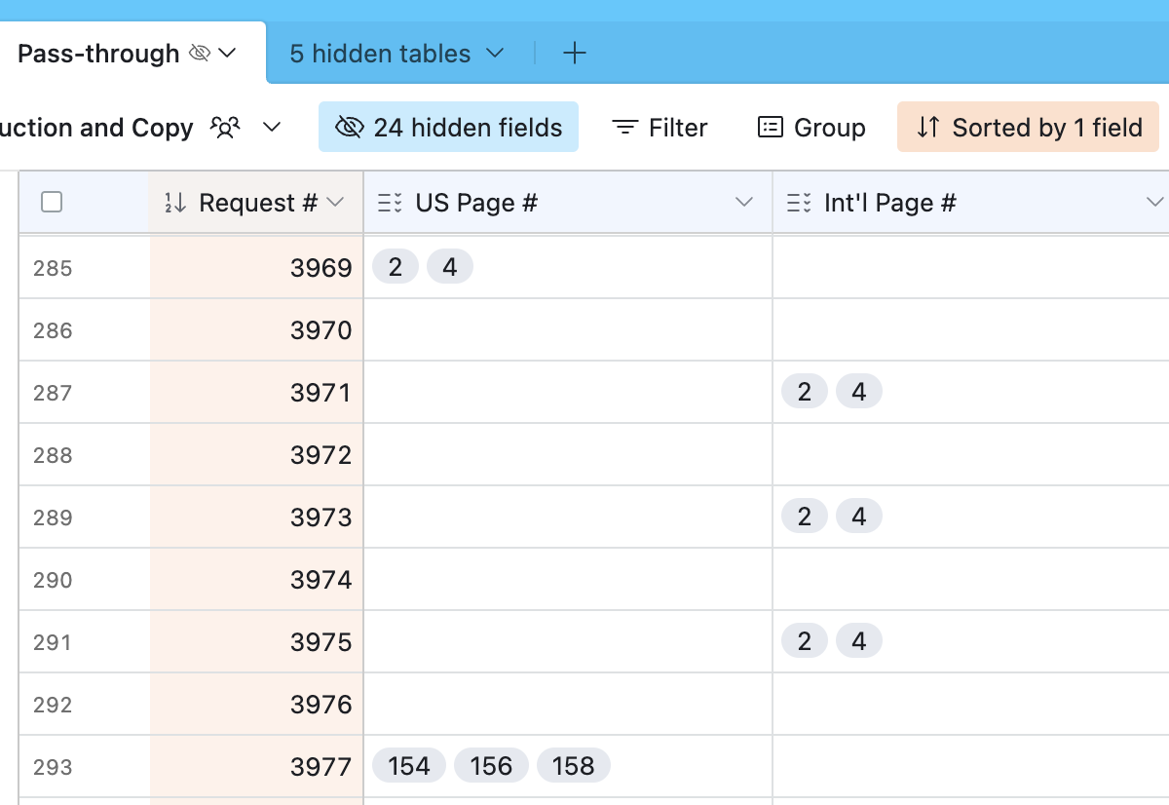

Pass-through table

These multi-page records will cause the automations that calculate Spread Letters, Project Codes, and International Page Numbers to fail. They will also clutter up the grid views and interfaces where Merchants can view their requests and where PAs and Copy Editors work. A standard workaround for this type of record is to snag it in a pass-through table and then use another table for the single-page records and the actual work. That snagging action is what the Pass-through table is for.

That's one problem solved and another created, because a consequence of having 2 different tables is that a design change in one might need to be duplicated in the other.

Note that this applies *only* to fields that are present in both tables; the tables are not identical in content. Examples are the Lookup, Link, and Formula fields in the e-Cat Change Requests table but not the Pass-through table. Other examples are the Region 2, Region 3, and Region 4 fields in the Pass-through table that are used to populate a single Region field in the e-Cat Change Requests table.

There are 7 different places where you can edit a field: in the form, in the tables themselves, in the Manage fields tool for each table, and in the 2 interfaces.

* *If you change a field in the form*, that change is applied to the Pass-through table, and you must change it in the e-Cat Change Requests table as well—whether in the grid view, in the Manage fields tool, or an interface.
* *If you change a field anywhere else*, check to see whether you need to make the same change in the other table.

All this also applies to adding new fields and deleting existing fields.

#### Making changes

To add, delete, or edit a field, refer to [this page](https://support.airtable.com/docs/airtable-field-actions) in Airtable support.

**Note** that you may need to edit the Expanded record view as well. See [this Airtable support page](https://support.airtable.com/docs/airtable-interface-layout-record-detail) for instructions.

## Design notes

#### User requirements

Some RH users profess an inability to find out:

* page numbers for international e-cats
* spread letters
* project codes

Any design considerations must accommodate these limitations.

#### Interfaces

This base provides 2 **interfaces** based on the e-Cat Change Requests table. There is no interface for the Pass-through table since its purpose is solely to snag records with multiple page numbers; no one uses it for working or viewing.

##### The Merchants interface

Merchants and other form users can use this interface to view requests and make changes to their requests, in particular to set the Status to "Resubmitted" or "Approved online by Requester." This interface shows a subset of the fields that Production and Copy can view and use. Users can filter, group, and sort records. Users are restricted from adding records in this table because the complexity of entering page numbers (see Troubleshooting).

##### The Production and Copy interface

PAs and Copy Editors have an interface for tracking the workflow. It also allows users to filter, group, and sort records without affecting other users. Most users can change the values in fields, but extra privileges are required to edit, reorder, hide, and unhide fields.

#### The garage

"The garage" is RH's affectionate name for the public grid view of the e-Cat Change Requests table. It provides an environment where the tools are hanging on the wall and authorized users can get under the hood to view hidden fields and change history and to make changes to the base, including the fields, lookup tables, and automations.

Copy Editors and PAs all have sufficient privileges to process change requests in the garage.

##### Hidden fields

Viewable in the garage are 20+ "man behind the curtain" fields that are typically hidden. These fields are necessary for performing back-end magic such as lookups, links, and formulas, but they don't provide any information that's necessary for the workflow (as the Status, PA, and Editor dropdowns do). They could provide diagnostic information if needed.

##### Hidden tables

Viewable from the garage are the lookup and Pass-through tables. They are typically hidden so users won't accidentally make changes.

## Troubleshooting

A record in the e-cat Change Requests table is missing the Spread Letter and/or Page.

The entries in the form are invalid, e.g., the user has entered:

* Region = GB
* Book = Outdoor
* Int'l Page = 600

where there is no Page 600 in GB Outdoor, or the user has entered:

* Region = GB
* Book = Modern
* US Page # = 300

where the spread on US page 300 is not included in the GB book.

I'm getting a Failure notification on the "Update ECR links and lookups" automation that says "Insufficient privileges to create row."

See the issue immediately above; someone made an invalid entry and the lookup has failed.

NOTE that this failure will also add a bogus row to the bottom of the Page Numbers table. If the table has been sorted on the primary field at some point, you can find the bogus row(s) by sorting on the Spread Letter or Page, which will be blank.

Delete the bogus rows.

Bogus rows are being added to the Page Numbers and Spread Letters tables.

See the issue immediately above.

One of the fields in the Expanded record view says "Invalid Size" or "Field Deleted."

A field was added, changed, or deleted, and the Expanded record view layout needs to be updated. See [this Airtable support page](https://support.airtable.com/docs/airtable-interface-layout-record-detail) for instructions.

A user says they can't change the Page number in the Expanded record view or the Merchants interface.

The "Page" field is a lookup field, so it can't be changed directly. If a user needs to change the page number, they should set the Status to HOLD and create a new request.

Spread Letters and Page numbers have disappeared in the e-cat Change Requests table.

This will happen if the backlinks from any of the 3 lookup tables are deleted. You should be able to retrieve them from the Trash. The records you're looking for will be called "e-cat Change Requests" and "e-cat Change Requests copy."

Backlinks

## Future development

### Improvements

The user experience for the e-Cat Change Requests form might be improved by certain changes.

**Multiple changes on a single submit** (not just multiple pages and regions) might be a minor improvement. Significant effort (8 hours per additional field group?) would be required to build this out, and it would safely max out at an additional 3–4 field groups given Airtable's 50-automation limit per base. It would be facilitated if Airtable adds capabilities for nested loops and a "Save and Continue" action within a form.

Multiple requests on a single submit

**A multiple select field for additional regions** would be a minor improvement to the user experience, although it would work only under specific conditions. The effort to build it (8–16 hours?) and the elaborate logic might not be worth the return. It would merit investigation if RH significantly expands the number of Regions, potentially requiring users to apply a single change to, e.g., 10 Regions. An **extension** *(Create records from multiple select field options)* for this purpose has been added to the base. There has been limited success with it in testing; someone who understands scripts and who can integrate the extension with existing automations might be able to make it work.

Multiple select field for additional Regions

### Hazards

**If RH changes any offerings or any organizational structures** that are reflected in the e-Cat Change Requests base, this will necessitate changes to the relevant fields and automations. Examples are adding Regions, shuffling or renaming Departments or Categories, changing the naming system for project codes, changing the algorithm for the live URLs, and adding, renaming, or removing Books.

### Airtable wish list

* **Nested loops.** If Airtable adds this feature, you will be able to remove the automations that loop on Region 2, Region 3, and Region 4 (at a minimum), and you may also be able to roll some single select fields into a multiple select field.
* **Performing a calculation based on a calculated field.** As it stands, you cannot calculate a Spread Letter (based on Region, Book, and US Page # input) and then look up an International Page Number based on that Spread Letter. If Airtable adds this feature, you will be able to do so without the elaborate workarounds (the "Faux-US" fields and automations) in the e-Cat Change Requests base.
* **Custom button after form submission.** The button to return to the e-Cat Change Requests form to submit another request says "Submit another response." "Response" is not an ideal term for us; "Change Request" or "Request" would be better, but Airtable does not allow customization of this button. If Airtable adds this feature, you will be able to change the button text to something more appropriate.

## Additional resources

Join the [Airtable community](https://community.airtable.com/) and consult [Airtable support](https://support.airtable.com/). YouTube also has some useful videos.

The automations, tables, and fields have brief **descriptions** intended to provide insight and guidance on their purpose and function.

Description of automation

To gain deep insight into the automations, formulas, links, and lookups in the e-Cat Change Requests base, pretend it doesn't exist and build it from scratch, guided by the User requirements and the principle of doing as much back-end work as possible for all users. Or create a test base and take a stab at the **Multiple changes on a single submit** proposed improvement.

## Links and navigation

Airtable.com:

"The garage": <https://airtable.com/appnilBkoUTrZN2qq/tblqZTABK6hW7JZxL/viwr1v14RPLZHCV6o>

Interfaces

Merchants interface: <https://airtable.com/appnilBkoUTrZN2qq/pagqCDXtFFw4U5fj0>

Production and Copy interface: <https://airtable.com/appnilBkoUTrZN2qq/pagiZ5XXovDjXjE0V>

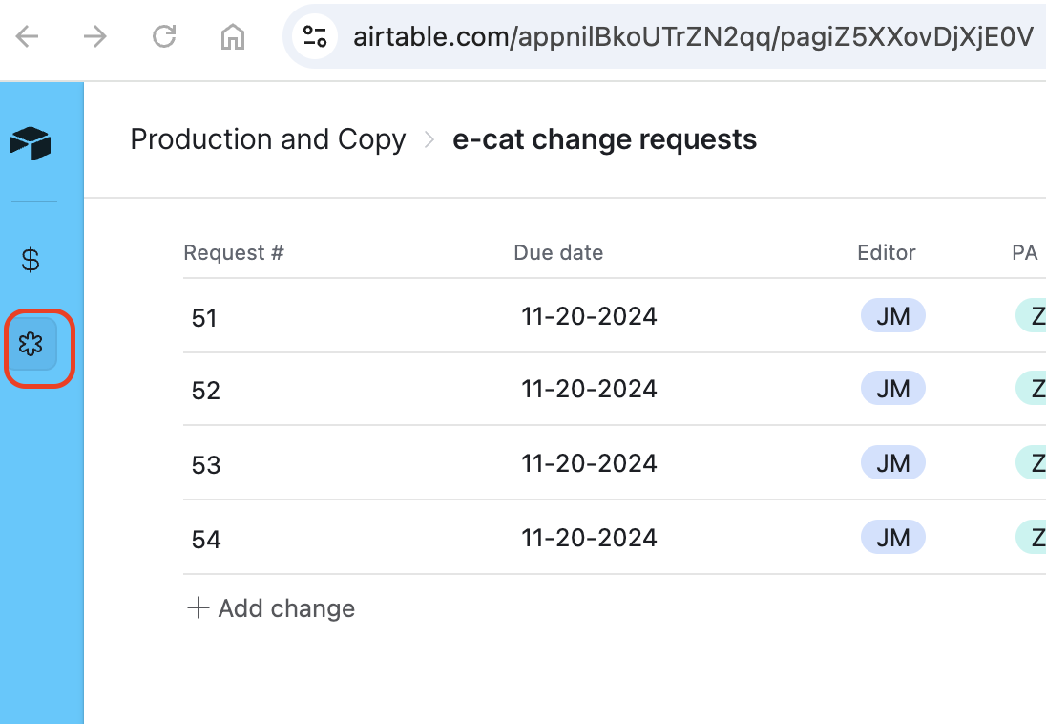

Form: <https://airtable.com/appnilBkoUTrZN2qq/pagg72TSurW5heuw3/form>

